STUDENT COLLEGE WEEKLY NEWSLETTER
DATE 09.05.2025
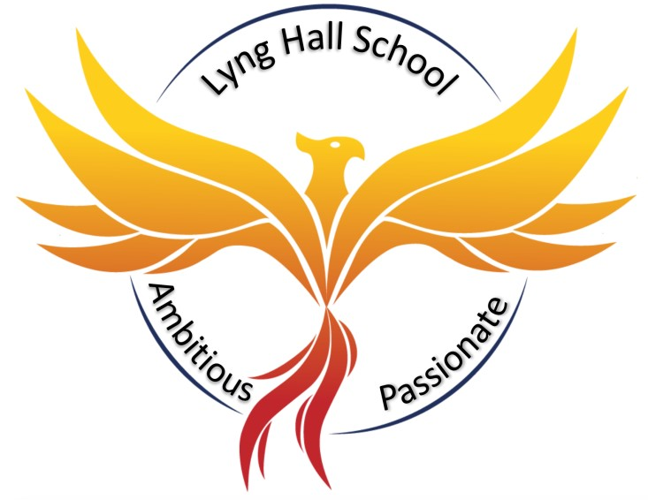

Important Dates For Your Diary
See the back page for important dates. 
Did You Know?
It is always inspiring to see what students at Lyng Hall can really achieve, when they are guided and become involved in enrichment. It was also inspiring to receive the letter, which highlights how well the students presented themselves and the school once again. It references the, ‘maturity, thoughtfulness and curiosity’ that Lyng Hall students demonstrated, alongside the committed focus of the staff involved.

We always tell students, staff, our community, that ’We Are Lyng Hall.’ The people in the building and the parents play a huge part in the reputation we have. At our best, we have many students who excel at any opportunities that are given to them make us proud in the wider arena.

Please take the time to read the lovely letter from SACRE and the articles from those involved that follow. There are lots of opportunities to shine for those who wish to go beyond the classroom and this edition is witness to some of those who took that chance,
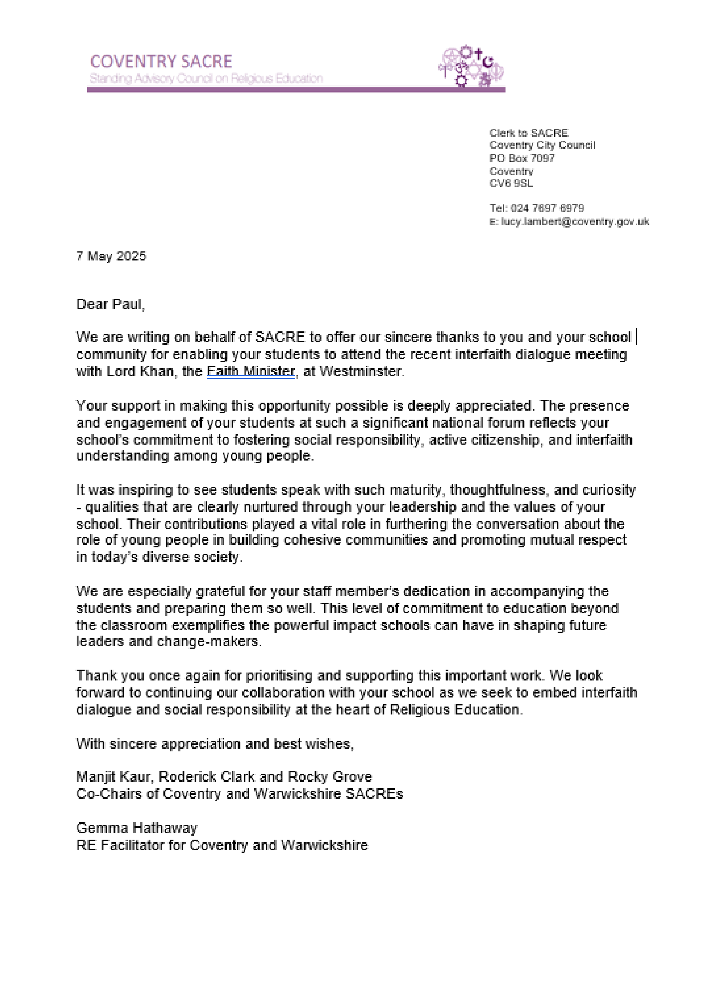

In recognition of the speeches delivered by Emmanuel and Julien at the SACRE conference in November, we were invited to a special event in London, at the invitation of Lord Khan, Minister of Faith.
During this visit students had the opportunity to observe the House of Commons in action—Ed Miliband fiercely debating how we will reach Net Zero. Working alongside other schools, they then participated in a
Poetry Activism workshop at The Surveyor’s House, before returning to Parliament for an audience with
Lord Khan in the House of Lords. We were additionally joined by our Coventry South MP—Zarah Sultana.
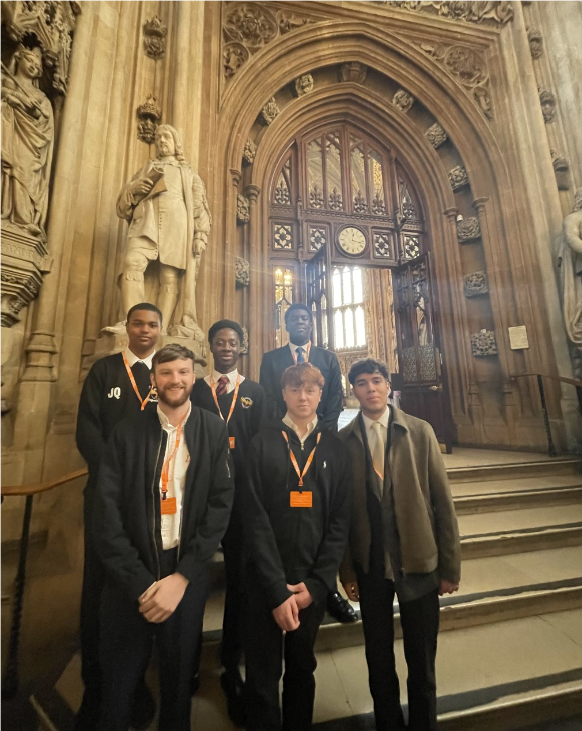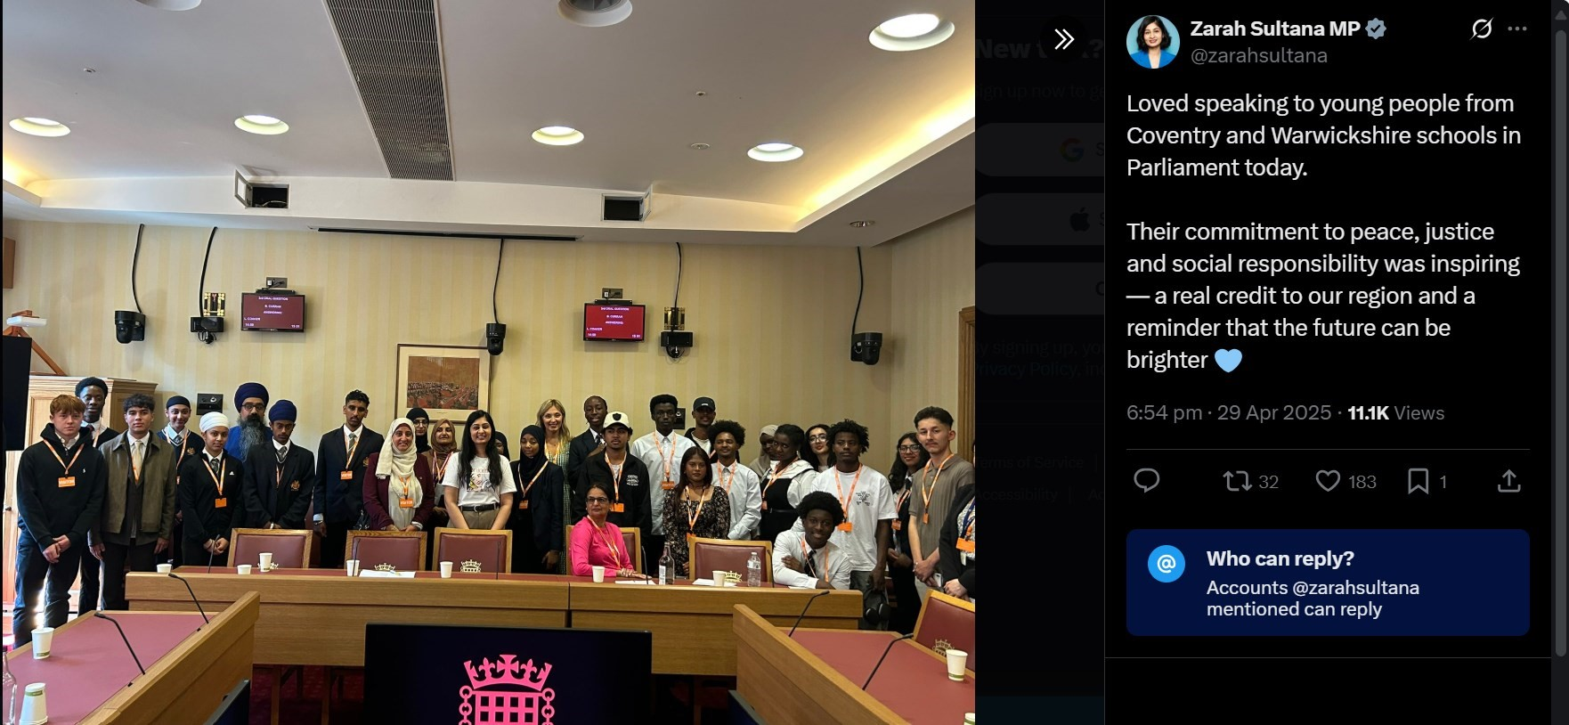
“
Visiting the Houses of Parliament was an inspiring ex-
perience that gave me a real insight into how decisions
are made in our country. Watching a live debate and
meeting Zarah Sultana, the MP for Coventry South,
made me feel proud to be from Coventry. She spoke
passionately about representing our city and standing
up for young people, showing how someone from our
community can make a real difference. Meeting the
MP for faith also highlighted the importance of unity
and diversity
-

values that truly reflect what Coventry
stands for. Both MPs emphasised how much power the
next generation holds, encouraging us to stay in-
formed, get involved, and be the future voices of
change. This visit was inspiring because it showed that
real change is possible and that young people like us
have a voice that matters. It left me feeling motivated,
proud, and more connected to Coventry and its role in
national decisions.
”
Maximus Linca
—
Y12 student

“Poetry is the language of human emotion – the breath in our lungs – the might of one person and the echo of millions” - Rupi Kaur
At Surveyor’s House, I led a poetry workshop with the different schools. Students were given a range of different prompts. Each encouraged them to consider the importance of faith and identity; but more significantly how our voices could be used to be activists of changed. They were challenged to create pieces that promoted inclusive and safe spaces—we look forward to sharing how this project will feature in our city’s community.
Dear Society,
We sit in this room as lights burning, our potential flickering on the edge of tomorrow. But a haunting chasm is ripping through the safety of our home. It needs to be stopped. It must end. But only through the devotion of us as a united force can the rupture be healed. We need to have collective faith that although the perception of young people is in a precarious position, we have the power to renew this image. To ignite a generation who have a conviction and hunger for a new future. Without the shadow

of a blades that bring harm to our society.
I hear the story of someone who is just a shadow now.
More living seed separated from life.
A haunting chasm is ripping through the safety of our home.
The story – they are just a story now.
A name on our tongues, and in our memories.
We sit in this room as lights burning, our potential flickering on the edge of a tomorrow where it stops.
The haunting chasm must end.
They need to be more than a story and a name – precious wings of life.
How to conquer violence
The voice of my father
The obsidian blanket that has been cast on us
Their sacred body scarred with rivers of red
Someone who dreamt of a paradise but was sliced into reality.
Hundreds painted in scarlet
They’re final words all begging for an answer.
Each life is more precious, more lustrous than a jewel.
Thou shalt not kill.
These beliefs are a remedy, if we all drank from this chalice of peace.

Hope called out to us—its fragile form blossoming inside our circle,
In a human chain.

“When we all went to visit Parliament in London, it was a very exciting experience. An opportunity for us to see it for ourselves in real life, and even witness a live tv debate. This was a very interesting experience, speaking to members of the Parliament and hearing what they had to say and even had the chance to ask them any questions we had for them. From that trip, we managed to grow our knowledge even further and understood different opinions about what it means to be a member of Parliament.
Lord Khan was here to answer any questions we had for him, and it was another opportunity to learn more from him after meeting him last time in November. It was not just about learning and our knowledge, but also a time of fun which we were able to take part in many activities.
We managed to write poems about different themes, some examples were light, cuts, belonging. Writing these poems allowed us to prepare ourselves to ask questions for Lord Khan and understand the true problems we are facing in this world, and ask ourselves questions that we wanted answered. Whilst going around Parliament, we got to have a tour and saw many parts of history and key figures. After asking questions to Lord Khan, we learnt that there are many problems Parliament is trying to solve and that it was not easy to do so. However, we also met MP Zarah Sultana, who was the first Muslim woman to be in Parliament. Although it an amazing achievement, we learned that she received hate. But even in hard times, she managed to persevere and fight for what she believes is right. Because of this, she is now a role model and an inspiring figure for all of us and someone many people look up to. It was a true inspiration to meet her and spend time with her. It is illustrative that we all have the potential to change our community.” - Julien Quesney, Y10 student, UNESCO Ambassador
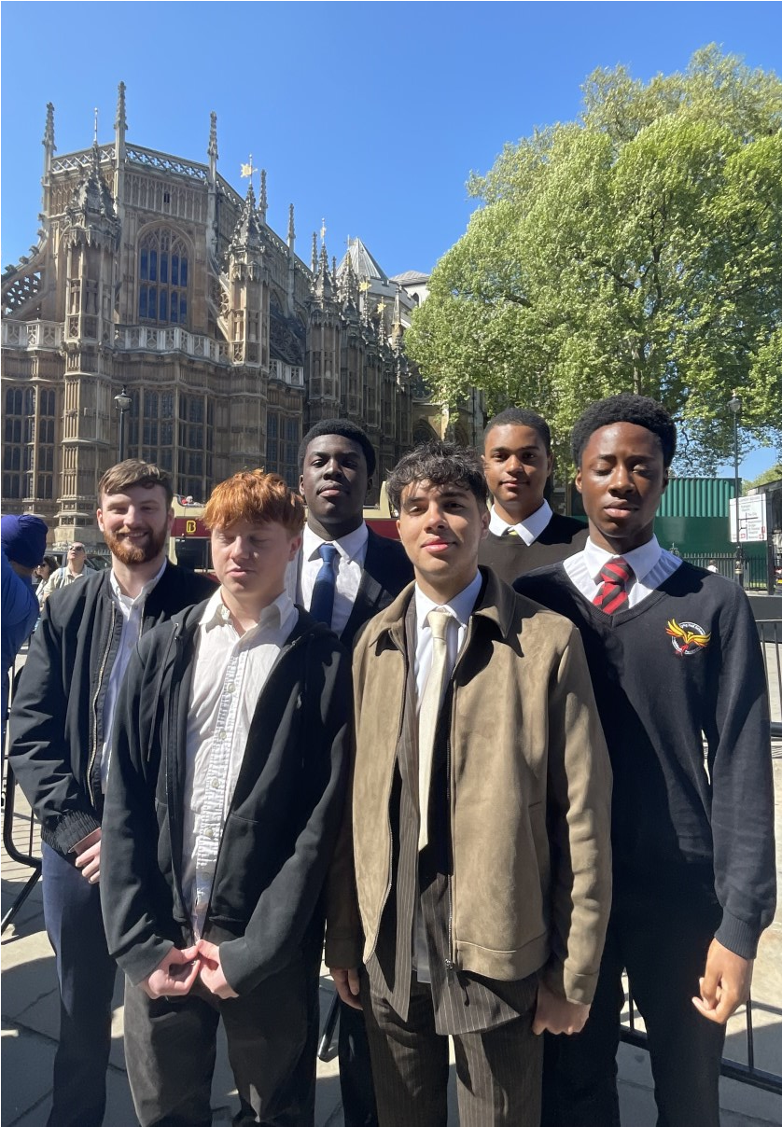
“A trip to Parliament is always special in any context, but representing the school as a member of staff was extra special. The students were able to sit in on a live debate in the House Of Commons, which was a real treat, where they got to see a small part of the inner workings of our country. It was something that I also found particularly informative as someone who's very interested in British politics. Meeting Lord Khan and Zarah Sultana MP for Coventry South was another special moment. Seeing how passionate they were about not just faith in schools, but the overall development of children's understanding towards culture was something that really touched me and left me feeling very optimistic that there are always people fighting the good fight..”
Mr. Baldwin, P16 Pastoral Year Coordinator
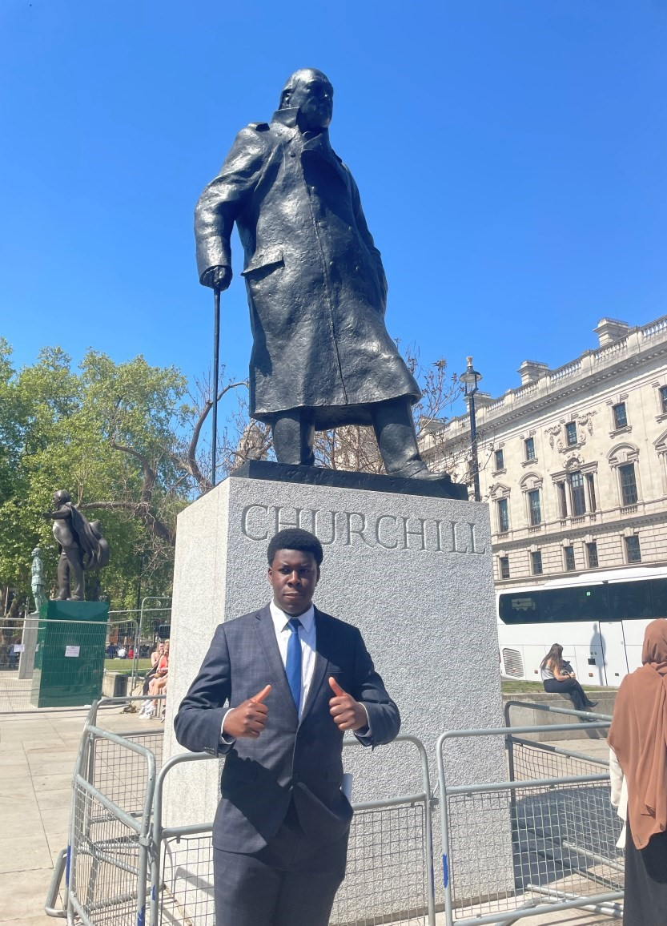
“Being given the opportunity to visit parliament is a proud achievement for me as I currently study law and I felt that this trip has further strengthened my understanding of how the law -making process in parliament works. Listening to a live debate and seeing Zarah Sultana, the Coventry South MP, made me proud to be a Coventrian. She discussed how much passion goes into serving our city and standing up for the young people, and how someone in our own city can make the impact. Meeting the faith-based MP also showed the importance of unity and difference - the very thing Coventry is all about. Both MPs discussed the immense power that the youth have, how we need to keep ourselves informed, get involved and be the champions for change in the future. This visit was inspiring because it showed that change was possible and that young people like us have a voice that gets listened to. It made me enthusiastic about Coventry and how it plays a part in national decisions.” - Joshua Solomon, Y12 Student
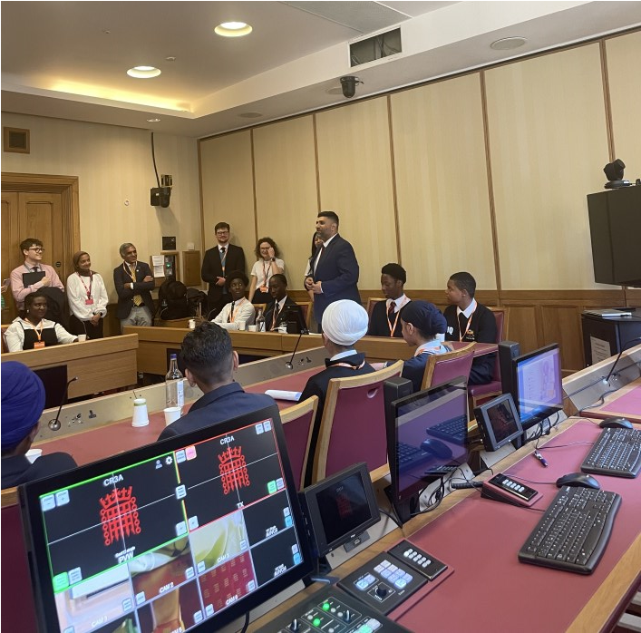
“It was wonderful to continue the powerful dialogue and creative expressions with the seven schools/colleges from across Coventry and Warwickshire on themes of interfaith cohesion and young voices. I look forward to sharing the poetry and developing the collaboration with our key partners.” Gemma Hathaway, RE Facilitator for Coventry & Warwickshire (on behalf of both SACRE’s)
"I was proud to join the group of young people at the houses of Parliament . Our amazing youngsters posed challenging and thoughtful questions to Lord Khan and Zarah Sultana." Manjit Kaur—Skills, Employment and Adult Education, Regeneration & Economy Directorate, Coventry City Council
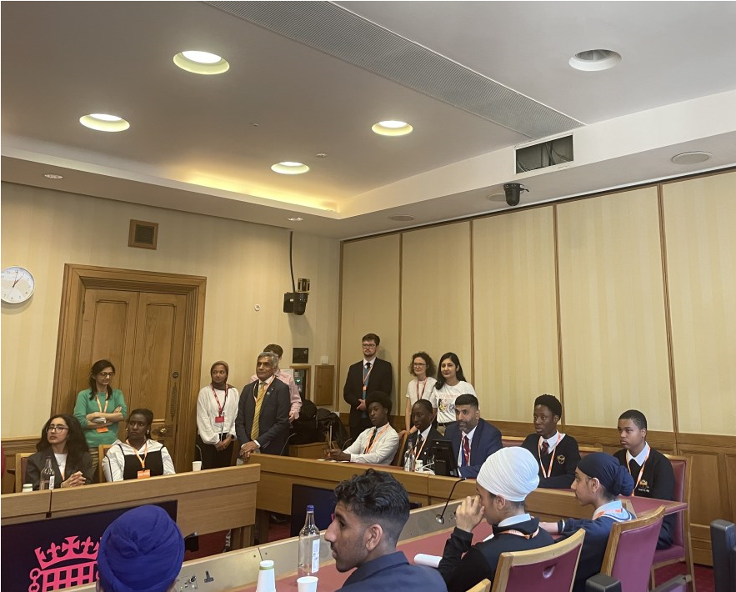
“Visiting the Houses of Parliament was genuinely inspiring.
Seeing a live debate and meeting Zarah Sultana, our MP for Coventry South, made me feel proud of where I’m from. She spoke with real passion about standing up for young people and showed that someone from our city can actually make a difference. Meeting the MP for faith also hit home—he spoke about unity and diversity, which really reflects what Coventry’s all about. Both MPs reminded us that young people have real power. I left feeling proud, motivated, and like our voices actually matter in shaping the future.” - Jamie Field, Y12 student
“Being given the opportunity to visit parliament is a proud achievement for me as I currently study law and I felt that this trip has further strengthened my understanding of how the law -making process in parliament works. Listening to a live debate and seeing Zarah Sultana, the Coventry South MP, made me proud to be a Coventrian. She discussed how much passion goes into serving our city and standing up for the young people, and how someone in our own city can make the impact. Meeting the faith-based MP also showed the importance of unity and difference - the very thing Coventry is all about. Both MPs discussed the immense power that the youth have, how we need to keep ourselves informed, get involved and be the champions for change in the future. This visit was inspiring because it showed that change was possible and that young people like us have a voice that gets listened to. It made me enthusiastic about Coventry and how it plays a part in national decisions.” - Joshua Solomon, Y12 Student
“It was wonderful to continue the powerful dialogue and creative expressions with the seven schools/colleges from across Coventry and Warwickshire on themes of interfaith cohesion and young voices. I look forward to sharing the poetry and developing the collaboration with our key partners.” Gemma Hathaway, RE Facilitator for Coventry & Warwickshire (on behalf of both SACRE’s)
"I was proud to join the group of young people at the houses of Parliament . Our amazing youngsters posed challenging and thoughtful questions to Lord Khan and Zarah Sultana." Manjit Kaur—Skills, Employment and Adult Education, Regeneration & Economy Directorate, Coventry City Council
“Visiting the Houses of Parliament was genuinely inspiring.
Seeing a live debate and meeting Zarah Sultana, our MP for Coventry South, made me feel proud of where I’m from. She spoke with real passion about standing up for young people and showed that someone from our city can actually make a difference. Meeting the MP for faith also hit home—he spoke about unity and diversity, which really reflects what Coventry’s all about. Both MPs reminded us that young people have real power. I left feeling proud, motivated, and like our voices actually matter in shaping the future.” - Jamie Field, Y12 student

